EXPNO 11: CREATE A CLONING OF A VM AND TEST IT BY LOADING THE PREVIOUS VERSION/CLONED VM.
AIM: To create a cloning of a vm and test it by loading the previous version/cloned vm.
PROCEDURE:
step 1: go to vm and goto manage and click clone
step 2: click clone
step 3: select the full clone
step 4: after clone again or vm is opened.
IMPLEMENTATION:
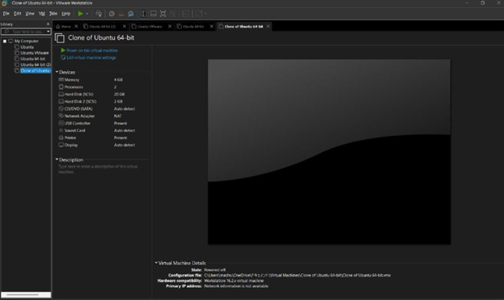

RESULT: thus,it was successfully completed

